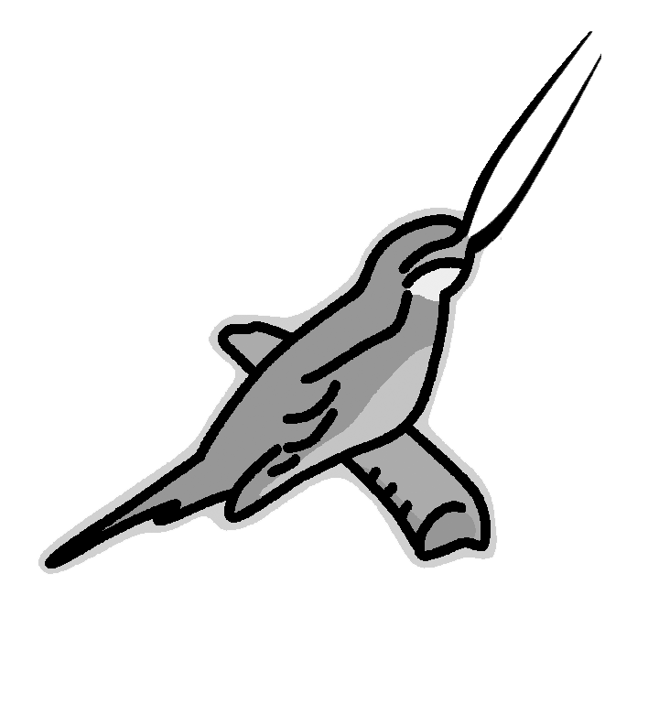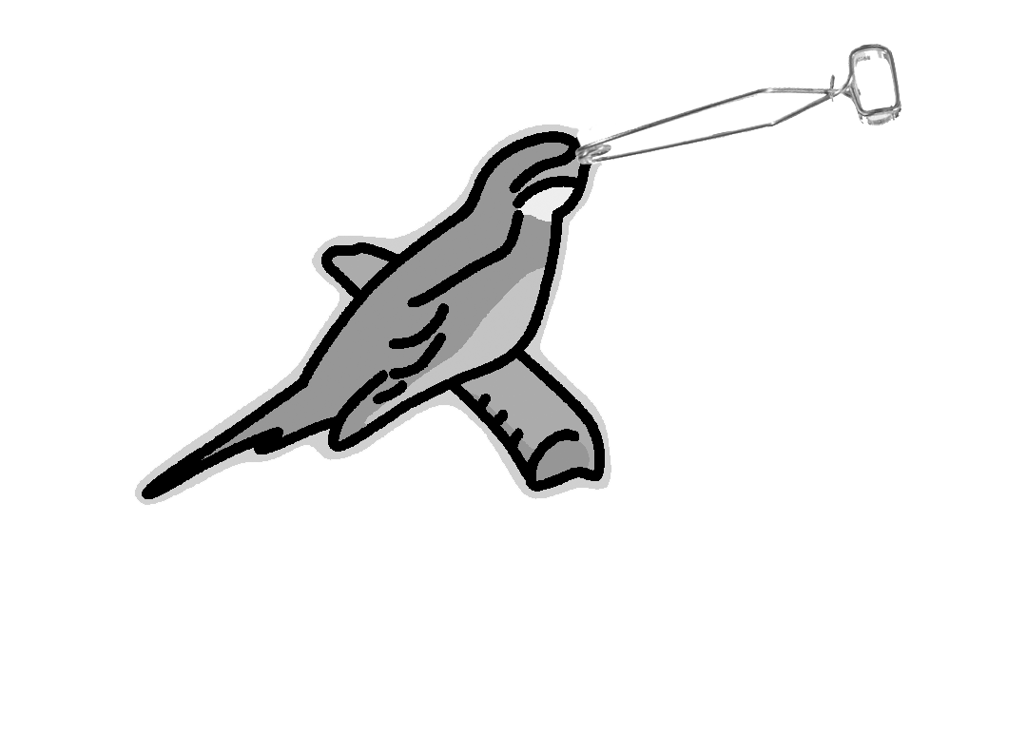

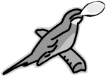

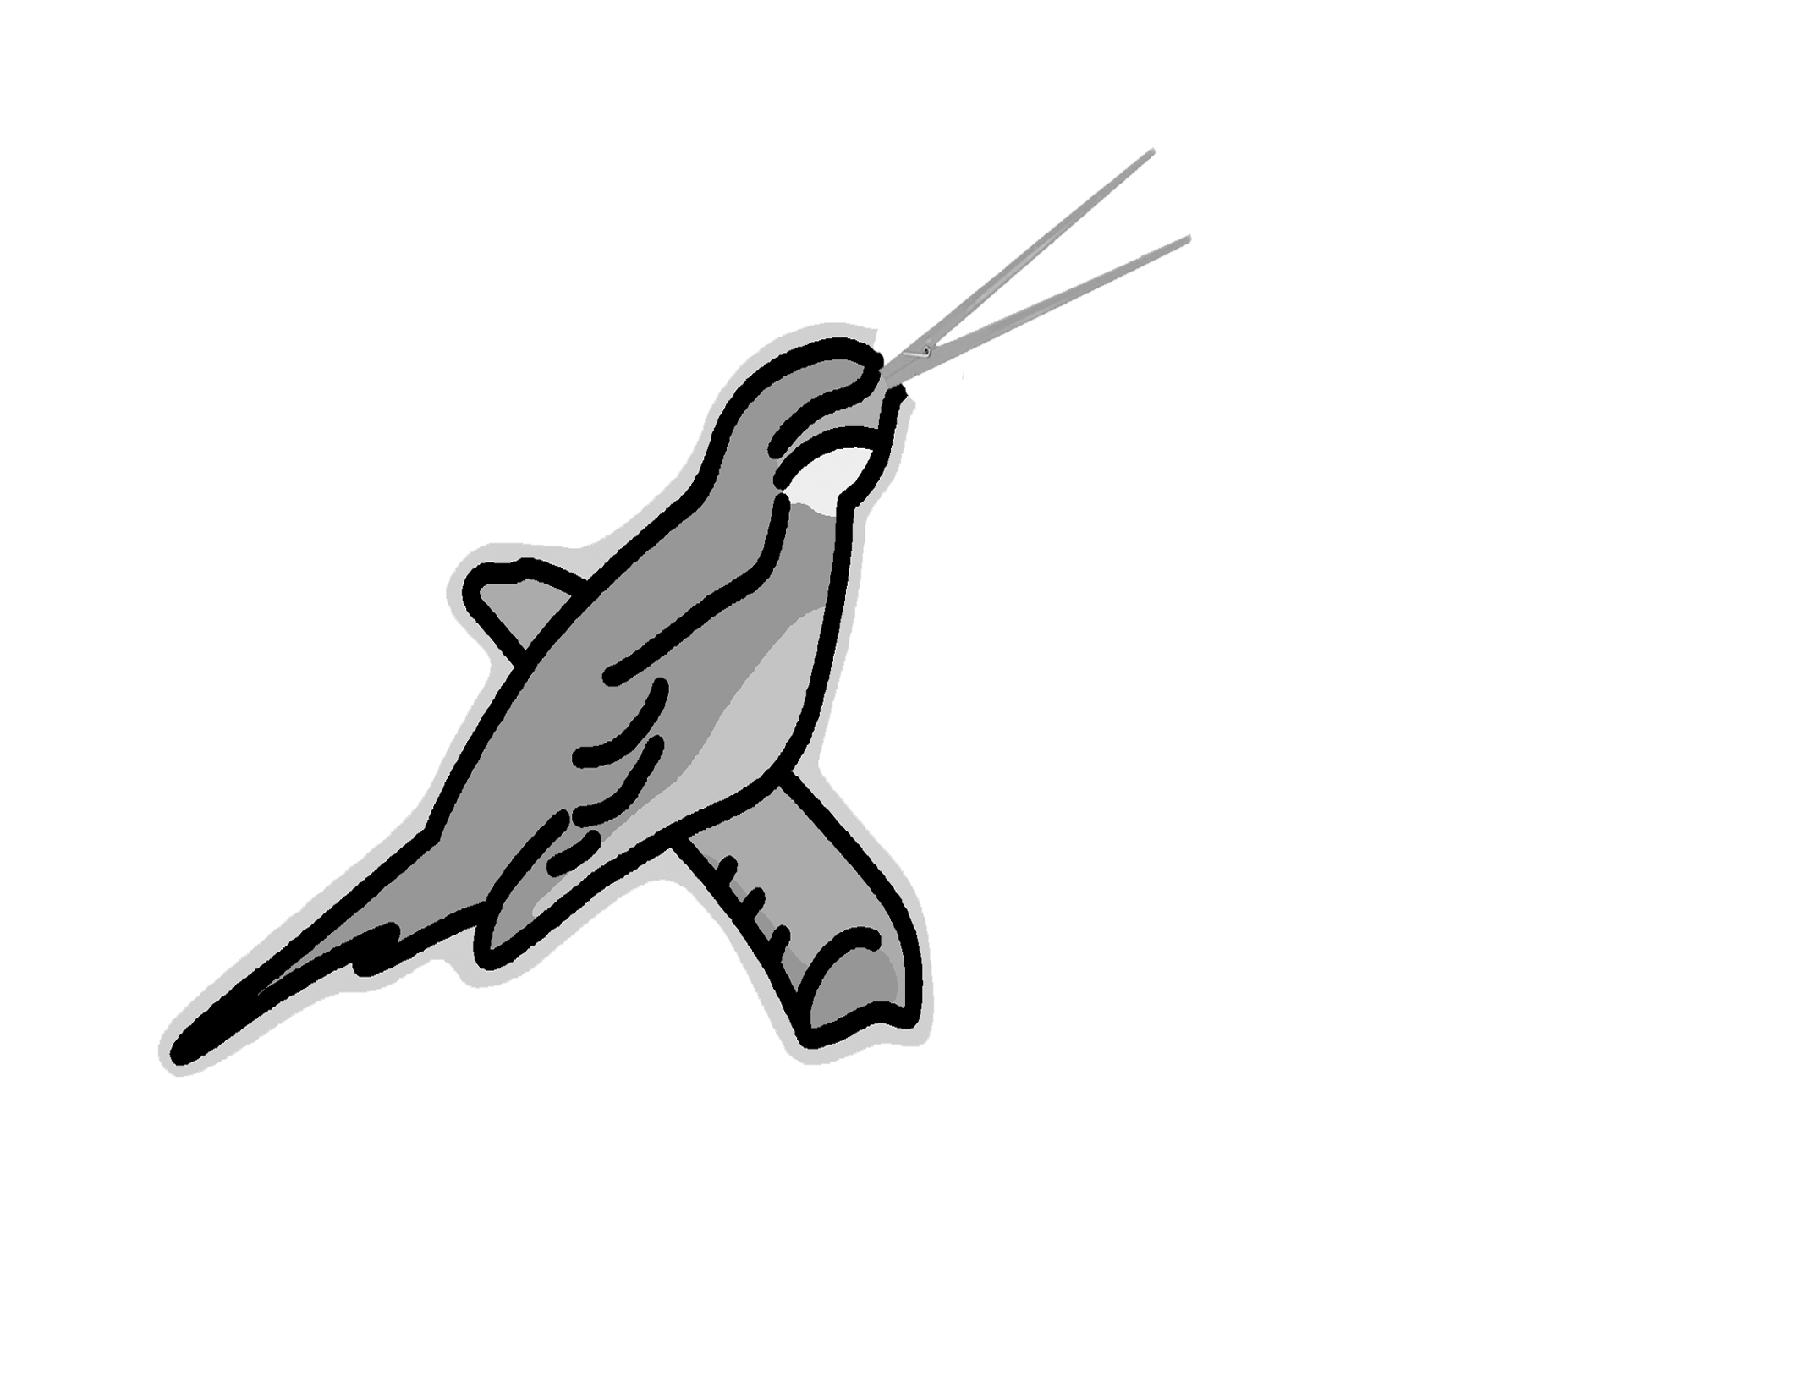

Adaptation Lab

# Bird Beak Lab

## Background Information

An adaptation is a trait that helps an organism survive and reproduce. Beak shape and size is an example of an adaptation. In this lab, you will see how certain adaptations can increase the bird’s chances of acquiring food. You will use utensils such as clamps, forceps, chopsticks, and spoons to represent a type of bird beak. You will then use utensils to pick up food as represented by toothpicks (worms), pennies (bugs), marbles (fruit), and beans (seeds). The cups represent the bird’s stomach.

## Problem

Which beak type is best adapted or suited to obtain certain foods?

## Hypothesis *Which bird beak is best suited for eating worms?______________*

*Which bird beak is best suited for eating bugs?* ***______________***

## *Which bird beak is best suited for eating fruit? ______________*

*Which bird beak is best suited for eating seeds?* ***_____________***

## Materials

|  |  |
| --- | --- |
| Clamps  Forceps  Chopsticks  Spoons  Toothpicks  Pennies | Beans  Marbles  Cups  Calculator  Time keeper |

## Procedure

1. Choose a beak type from the tray given in your group. Use the cup to represent the bird’s stomach. Use the utensils appropriately.
2. When the signal is given, you will have 15 seconds to try to put as much food as possible into the bird’s stomach. PUT ONLY ONE FOOD ITEM AT A TIME. DO NOT USE YOUR HANDS TO TOUCH THE FOOD!
3. Count and record the amount of food on Data Table I for the beak type.
4. Calculate group averages.

## Conclusion

1. How did variations in bird beak types affect survival of the birds?_____________________ ______________________________________________________________________________________________________________________________________________
2. How is this lab an example of evolution by natural selection?__________________________ ______________________________________________________________________________________________________________________________________________
3. Graph your results. You are graphing the Bird Beak type and the amount of food eaten. See sample graph.

## Data

DATA TABLE I: Individual Data and Group Averages

|  |  |  |  |  |  |  |  |  |
| --- | --- | --- | --- | --- | --- | --- | --- | --- |
| **Beak Types** | **# of Worms** (toothpicks) | **Group Average** | **# of Bugs** (pennies) | **Group Average** | **# of seeds**  (beans) | **Group Average** | **# of fruit**  (marbles) | **Group Average** |
| Clamps |  |  |  |  |  |  |  |  |
| Forceps |  |  |  |  |  |  |  |  |
| Chopsticks |  |  |  |  |  |  |  |  |
| Spoon |  |  |  |  |  |  |  |  |

|  |  |  |
| --- | --- | --- |
| **Food Name** | **Represented by** | **Calories** |
| Worms | Toothpicks | 10 |
| Bugs | Pennies | 15 |
| Seeds | Beans | 10 |
| Fruit | Marbles | 15 |

|  |  |  |
| --- | --- | --- |
| Beak Type | To Survive | To Reproduce |
| Large Beak (clamps, spoon) | 60 | 110 |
| Medium Beak (forceps) | 45 | 90 |
| Small Beak (chopsticks) | 25 | 50 |

###### Analysis: *Use your group averages to fill in the Analysis table.*

|  |  |  |  |  |
| --- | --- | --- | --- | --- |
| **Beak Type** | **Food best adapted to eat** | **Calories eaten with best food source** | **Did it survive with best food source?** | **Did it reproduce with best food source?** |
| Clamps |  |  |  |  |
| Forceps |  |  |  |  |
| Chopsticks |  |  |  |  |
| Spoon |  |  |  |  |

|  |  |  |  |  |  |  |  |  |  |  |  |  |  |  |  |  |  |  |  |
| --- | --- | --- | --- | --- | --- | --- | --- | --- | --- | --- | --- | --- | --- | --- | --- | --- | --- | --- | --- |
|  |  |  |  |  |  |  |  |  |  |  |  |  |  |  |  |  |  |  |  |
|  |  |  |  |  |  |  |  |  |  |  |  |  |  |  |  |  |  |  |  |
|  |  |  |  |  |  |  |  |  |  |  |  |  |  |  |  |  |  |  |  |
|  |  |  |  |  |  |  |  |  |  |  |  |  |  |  |  |  |  |  |  |
|  |  |  |  |  |  |  |  |  |  |  |  |  |  |  |  |  |  |  |  |
|  |  |  |  |  |  |  |  |  |  |  |  |  |  |  |  |  |  |  |  |
|  |  |  |  |  |  |  |  |  |  |  |  |  |  |  |  |  |  |  |  |
|  |  |  |  |  |  |  |  |  |  |  |  |  |  |  |  |  |  |  |  |
|  |  |  |  |  |  |  |  |  |  |  |  |  |  |  |  |  |  |  |  |
|  |  |  |  |  |  |  |  |  |  |  |  |  |  |  |  |  |  |  |  |
|  |  |  |  |  |  |  |  |  |  |  |  |  |  |  |  |  |  |  |  |
|  |  |  |  |  |  |  |  |  |  |  |  |  |  |  |  |  |  |  |  |
|  |  |  |  |  |  |  |  |  |  |  |  |  |  |  |  |  |  |  |  |
|  |  |  |  |  |  |  |  |  |  |  |  |  |  |  |  |  |  |  |  |
|  |  |  |  |  |  |  |  |  |  |  |  |  |  |  |  |  |  |  |  |
|  |  |  |  |  |  |  |  |  |  |  |  |  |  |  |  |  |  |  |  |
|  |  |  |  |  |  |  |  |  |  |  |  |  |  |  |  |  |  |  |  |